Yunlu Li

STAT 5120

Homework 7

Question 1

(a) The predicators giving the best value for all 5 criterions is

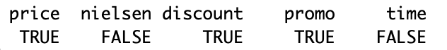

(b) The residuals generally fall in a horizontal band around 0 with no obvious pattern. The variance of the residuals appear to be constant. Thus, assumptions or the regression model are met.

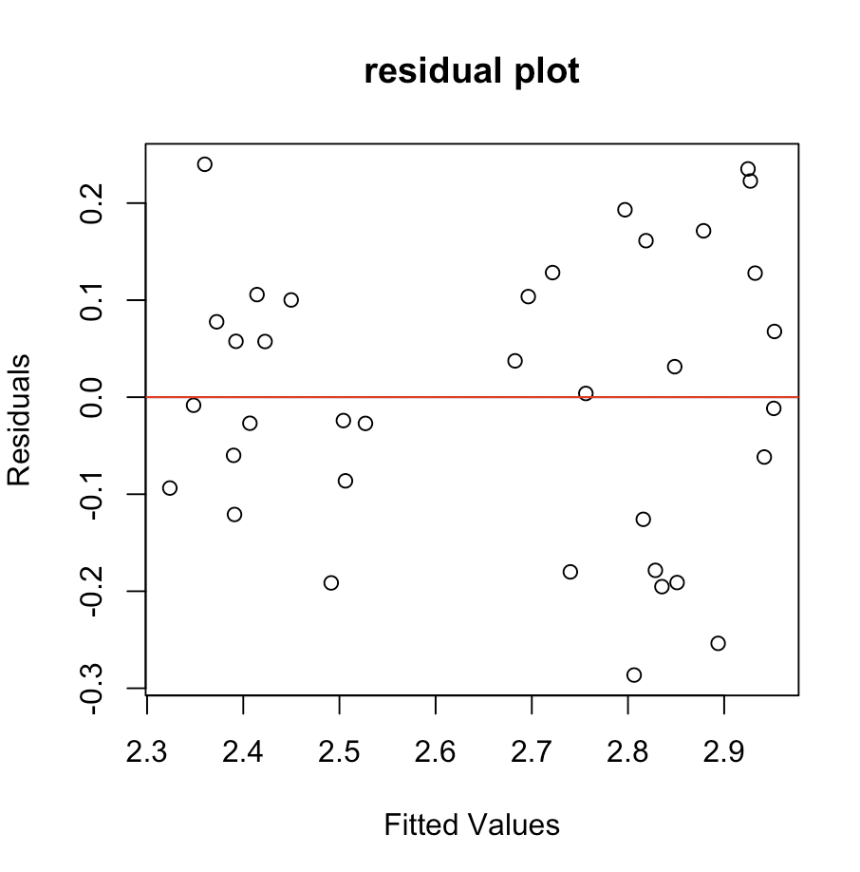

(c) The estimated regression equation is

$$Share=3.18527-0.35269*price+0.39914*discount+0.11803*promo$$

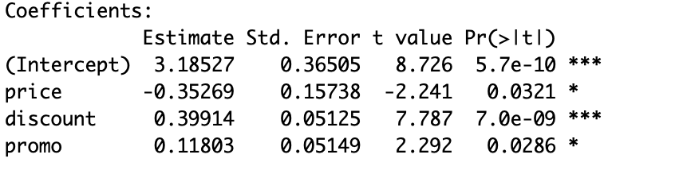

$β_{1}=-0.35269$ means that the estimated share decreases by 0.35269 percentage points for every one dollar increases in *price*, for given class of *discount* and *promo*.

$β_{2}=0.39914$ means that the estimated share is 0.35269 percentage points higher for discount price in effect than no discount, for given value of *price* and class of *promo*.

$β_{3}=0.11803$ means that the estimated share is 0.11803 percentage points higher for promotion in effect than no promotion, for given value of *price* and class of *discount*.

(d) The model giving best smallest AICp is

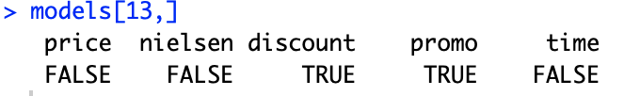

The model giving best smallest PRESSp is

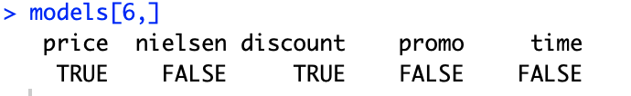

(e) For model 13, the PRESSp is 0.9797197 and SSEp is 0.8306269.

For model 6, the PRESSp is 0.9766704 and SSEp is 0.8358599.

The difference between SSEp with the PRESSp for model 6 with *price*, *discount* is smaller so model 6 is a better fit.

(f) The model based on forward selection consists of *price, discount,* and *promo.*

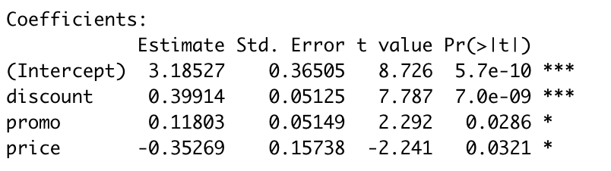

(g) The model based on backward selection consists of *price, discount,* and *promo.*

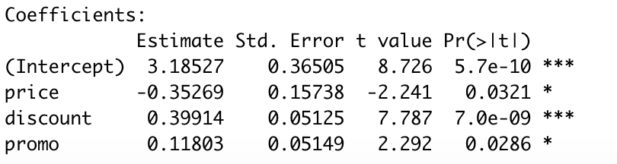

(h) The best model consists of *nielson, price, discount,* and *promo.*

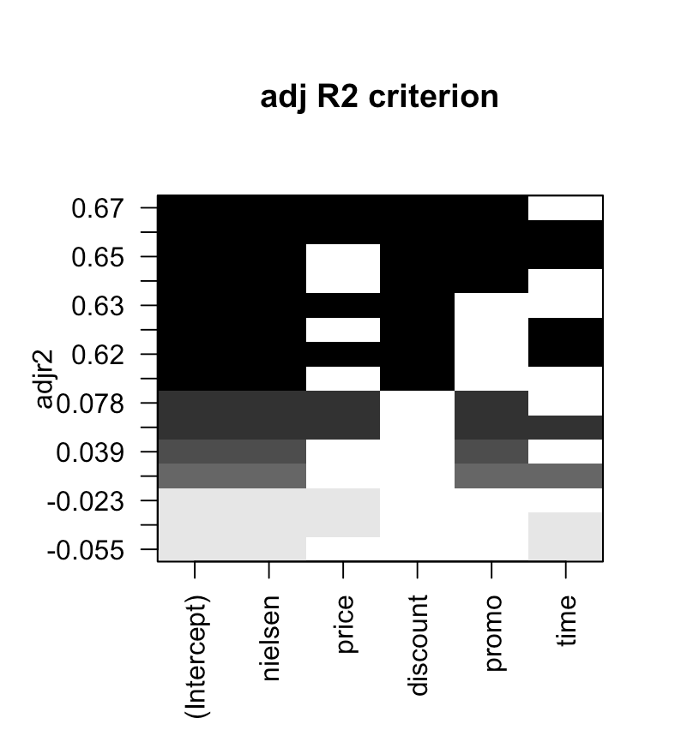

Question 2

(a)

Step 1: x4

Step 2: x4, x1

Step 3: x4, x1, x2

Step 4: x4, x1, x3, x2

(b)

Step 1: x4, x1, x3, x2

Step 2: x1, x2, x3

Step 3: x2, x3

Step 4: x3